Project Design Phase-II
Technology Stack (Architecture & Stack)

Date | 14 July 2026
Team ID | [Enter Team ID]
Project Name | AI-Powered Debt Relief & Financial Recovery Platform
Maximum Marks | 4 Marks

Technical Architecture:
The Deliverable shall include the architectural diagram as below and the information as per the table1 & table 2
Example: Order processing during pandemics for offline mode

Project Architecture Diagram:
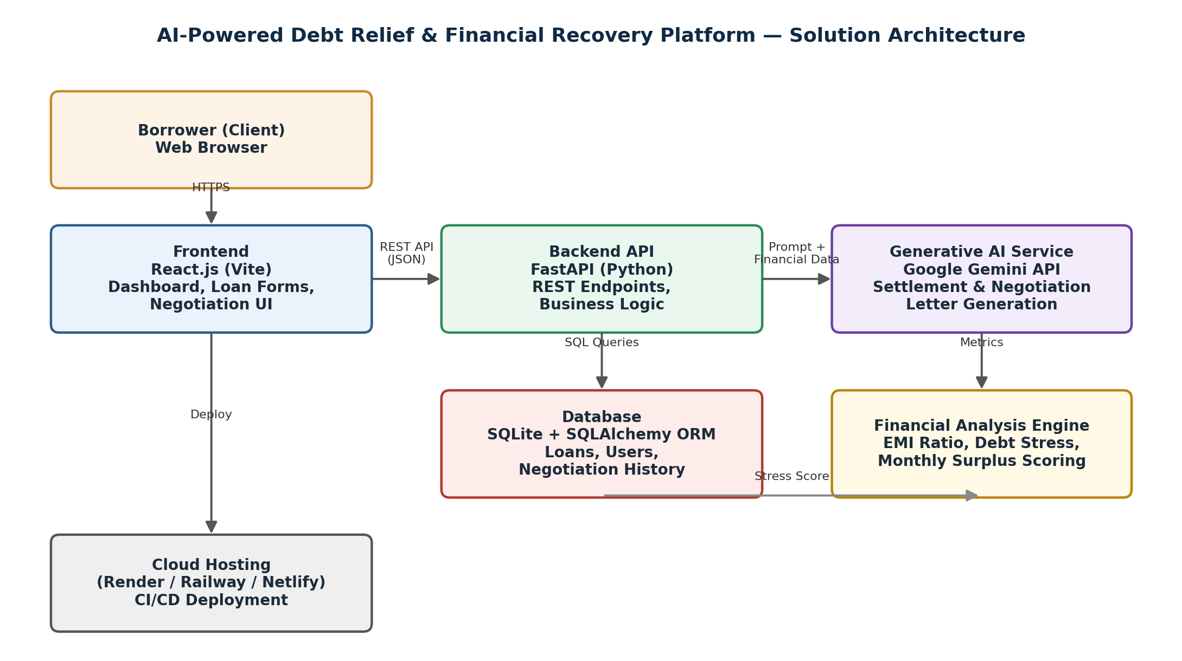
Reference: https://developer.ibm.com/patterns/ai-powered-backend-system-for-order-processing-during-pandemics/
Guidelines:
Include all the processes (As an application logic / Technology Block)
Provide infrastructural demarcation (Local / Cloud)
Indicate external interfaces (third party API’s etc.)
Indicate Data Storage components / services
Indicate interface to machine learning models (if applicable)


Table-1 : Components & Technologies:
S.No | Component | Description | Technology
1 | User Interface | Borrower-facing web interface for loan entry, dashboard, and negotiation letters | React.js (Vite), HTML5, CSS3, JavaScript
2 | Application Logic-1 | Loan CRUD, authentication, and request routing | FastAPI (Python)
3 | Application Logic-2 | Financial health computation (EMI ratio, surplus, debt stress scoring) | Python (custom rules engine)
4 | Application Logic-3 | AI-driven settlement recommendation & negotiation letter generation | Google Gemini API
5 | Database | Storage of users, loan records, and negotiation history | SQLite with SQLAlchemy ORM
6 | Cloud Database | Production-grade managed database service | PostgreSQL on Render / Railway (planned upgrade path)
7 | File Storage | Storage for generated negotiation letters / exports | Local filesystem (dev); Cloud object storage (prod)
8 | External API-1 | Generative AI for settlement analysis & negotiation drafting | Google Gemini API
9 | External API-2 | Email delivery for confirmation & negotiation letters (planned) | SMTP / SendGrid API
10 | Machine Learning Model | Debt stress classification & settlement percentage prediction | Rule-based scoring model + Gemini prompt-based reasoning
11 | Infrastructure (Server / Cloud) | Local Server Configuration: Uvicorn + FastAPI on localhost during development  Cloud Server Configuration: Render / Railway (backend), Netlify / Vercel (frontend) | Local, Render, Railway, Netlify

Table-2: Application Characteristics:
S.No | Characteristics | Description | Technology
1 | Open-Source Frameworks | React.js, FastAPI, SQLAlchemy, Vite are all used as core open-source frameworks | React.js, FastAPI, SQLAlchemy, Vite
2 | Security Implementations | JWT-based authentication, bcrypt password hashing, HTTPS, environment-based API key storage, input validation | JWT, bcrypt, HTTPS, python-dotenv
3 | Scalable Architecture | Stateless 3-tier architecture (frontend, API, database) allows the backend to be scaled horizontally behind a load balancer | 3-tier architecture, FastAPI async workers
4 | Availability | Cloud deployment on Render/Railway with automated restarts; frontend served via CDN-backed static hosting (Netlify) | Render, Railway, Netlify CDN
5 | Performance | Async FastAPI endpoints, indexed SQLite/SQL queries, and lightweight React components keep dashboard response under 2 seconds | FastAPI async, SQL indexing, Vite bundling

References:
https://c4model.com/
https://developer.ibm.com/patterns/online-order-processing-system-during-pandemic/
https://www.ibm.com/cloud/architecture
https://aws.amazon.com/architecture
https://medium.com/the-internal-startup/how-to-draw-useful-technical-architecture-diagrams-2d20c9fda90d

